Affordable Paradise

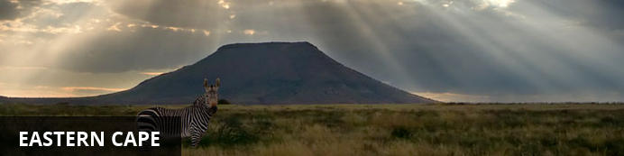
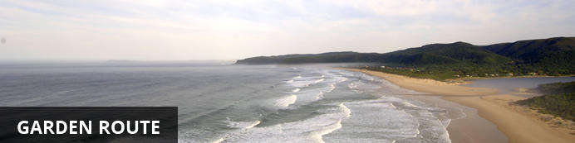
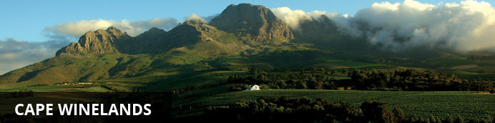
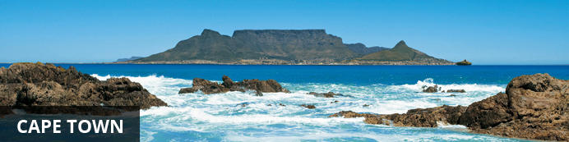

Affordable Paradise
Addo - Plettenberg Bay - Cape Town - Southern Suburbs - Kommetjie
13 Days / 12 Nights
Prices from £1,895.00 per person based on two sharing

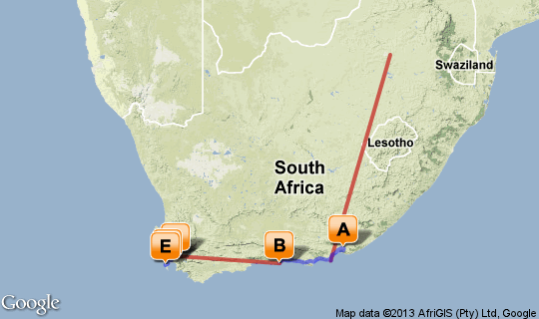

Click here to view your Virtual Itinerary

Overview
A great value self-drive trip to South Africa, beating the credit crunch and offering the highlife for a low price.
Prices from £1,895.00 per person based on two sharing.

Destination | Accommodation | Nights | Basis | Room Type
Addo | Amakhala Woodbury Lodge | 2 | FB+
Plettenberg Bay | The Robberg Beach Lodge | 2 | B&B
Cape Town | Hawksmoor House | 2 | B&B
Southern Suburbs | The Last Word Constantia | 2 | B&B
Kommetjie | The Last Word Long Beach | 2 | B&B

Key
B&B: Bed and breakfast. D, B&B: Dinner, bed and breakfast. FB: Dinner, bed, breakfast and lunch. FB+: Dinner, bed, breakfast, lunch and activities daily. FI: Fully inclusive.

Day 1: Travelling

Travelling

Days 2-4: Amakhala Woodbury Lodge, Eastern Cape

Eastern Cape
The Eastern Cape is renowned for its history, its beaches and more recently its great wildlife viewing opportunities.

Overnight: Amakhala Woodbury Lodge View iBrochure
Guests are accommodated in 6 comfortably appointed stone-and-thatch sleeping lodges, each with air-conditioning and en-suite bathroom. The seclusion of the lodges and the design of the bathrooms and private decks enable our visitors to enjoy the unique and breathtaking views at their leisure. Guests are often thrilled by the late afternoon sighting of the elephant herd passing by.
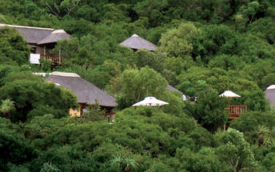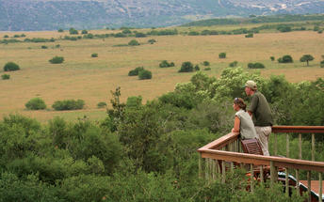

Included
Dinner, Bed, Breakfast, Lunch and Activities
Drinks (Local Brands)

Days 4-6: The Robberg Beach Lodge, Garden Route

Garden Route
With its great beaches along a narrow strip of fertile land nestled between majestic mountains and the big blue Indian Ocean the Garden Route is one of South Africa’s premier holiday destinations.

Overnight: The Robberg Beach Lodge View iBrochure
Robberg House offers guests all the luxuries of penthouse living, just stone's throw from the beach. Enjoy sundowners on the rooftop deck of Robberg House, with panoramic views of the ocean and Robberg Nature Reserve .
Robberg House offers a fresh modern luxury accommodation, with 5 luxury Rooms, 4 Luxury Suites and 1 Luxury View suite in Plettenberg Bay located in Garden Route of South Africa.
Guests are served a full Continental and a full English breakfast at the dining room and the veranda next to the pool of the Beachy Head Villa.
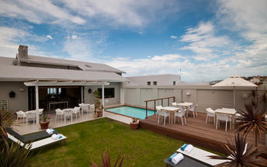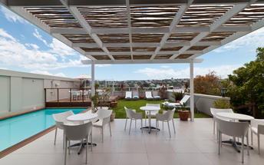

Included
Bed and Breakfast

Days 6-8: Hawksmoor House, Cape Winelands

Cape Winelands
A mere one hour drive from Cape Town lie the valleys and mountains which have become synonymous with some of the world finest wines. Spectacular mountain scenery, fine hotels and guest houses, 300 years of wine making history and many of the country’s top restaurants combine to make the Cape Winelands into a much desired destination. This is the centre of South Africa’s award winning wine industry and places of interest include Stellenbosch, Franschhoek and numerous award winning wine estates.

Overnight: Hawksmoor House View iBrochure
Hawksmoor House is a Cape Dutch country retreat located on a 220- hectare wine farm, Matjieskuil, near Stellenbosch in the Cape Winelands. Meticulously restored and beautifully decorated with exquisite antiques, it occupies a stunning location amidst vineyards overlooking Table Mountain, and enjoys spectacular sunsets.
A 25 minute drive away from the buzzing Cape Town centre, the estate is quiet and serene. In addition to our guests, the farm is home to horses, cows, porcupines, hawks, pelicans and countless other wildlife. Our resident German Pointers Cosmo, Max & little Alice keep a watchful eye on the daily workings of the farm.
If you love dirt roads, sunsets, wine by candlelight, an owl outside your window, and don't mind sharing the pool with the occasional disoriented frog, or getting a paw print of our overzealous dogs on your trousers, you have found your place!
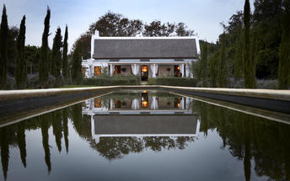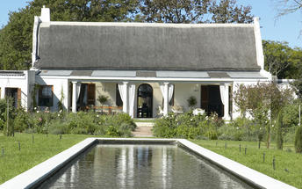

Included
Bed and Breakfast

Days 8-10: The Last Word Constantia, Cape Town

Cape Town
Cape Town is one of the world's most beautiful cities and a top international destination. Large volumes of tourist flock to Cape Town to enjoy this unique city with it's fascinating history, interesting culture, natural beauty, award winning wines and laidback lifestyle. Whether you are a serious tourist or just want to lie on the beach and enjoy life Cape Town will satisfy your needs.

Overnight: The Last Word Constantia
Situated in the Cape’s oldest and most beautiful wine valley, the five star The Last Word Constantia is close to seven of South Africa’s top wine estates and many internationally celebrated restaurants.
The Last Word Constantia is in a most exclusive area just one minutes drive from the chic Constantia Mall’s fashionable shops and restaurants. An easy approach to freeways gives guests superb access to all the Cape’s scenic delights, from Simonstown and the False Bay beaches to the City Centre, Waterfront and beyond. Golf lovers will be spoilt for choice with championship golf courses situated a stone’s throw away.
Great attention is paid to peace and tranquillity. An inviting sunken swimming pool and surrounding tanning deck is the focal point of the magnificently manicured garden with rolling lawns, vibrant colours and exquisite mountain views.
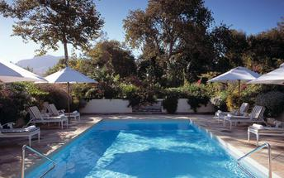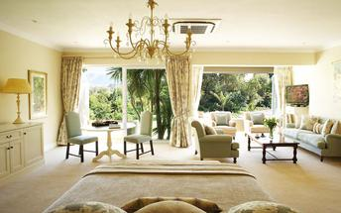

Included
Bed and Breakfast

Days 10-12: The Last Word Long Beach, Cape Town

Cape Town
Cape Town is one of the world's most beautiful cities and a top international destination. Large volumes of tourist flock to Cape Town to enjoy this unique city with it's fascinating history, interesting culture, natural beauty, award winning wines and laidback lifestyle. Whether you are a serious tourist or just want to lie on the beach and enjoy life Cape Town will satisfy your needs.

Overnight: The Last Word Long Beach
The five star The Last Word Long Beach is right on the beach in the picturesque lobster-fishing village of Kommetjie, a short 30 minute drive from Cape Town. The eight kilometres of fine white powdered sand set against a backdrop of the most stunning sea views offers Cape Town’s most romantic hideaway, one of just a handful of places where the sea is on your doorstep.
It is an unspoilt paradise in which to walk, ride horses, surf or simply laze in the sun. From the inviting pool or your private deck you can watch whales frolic a hundred meters off shore and in season, you can catch your own lobster and request it for dinner. Kommetjie is one of the premier surfing and marine birding hotspots in South Africa and has the country’s tallest cast iron lighthouse open to the public.
The The Last Word Long Beach has six ultra luxurious rooms all with stylishly comfortable interiors and private patios. Each spectacularly appointed room faces the sea – as do the bathrooms.
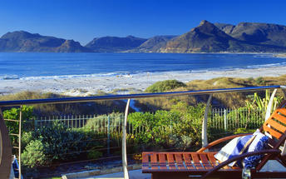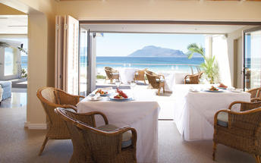

Included
Bed and Breakfast

Day 13: Travelling

Travelling

